**SOLANO COMMUNITY COLLEGE**

**MT 162, ROBOTICS**

Fall, 2018

SOLANO COMMUNITY COLLEGE

ROBOTIC SYSTEMS MT-162

**LAB 9: INPUTS / OUTPUTS**

**Catharine Crayne**

11/7/18

**OBJECTIVE**:

1. To learn how to configure and utilize I/O in a program.

**GROUP MEMBERS**

*Joel*

**MATERIALS**: RoboGuide and Laptop, Fanuc Robot w/gripper

**PROCEDURE**:

1. Power up the robot controller. Place the robot and pendant in Teach Mode.
2. Set up Robot Outputs 3 and 4 as complementary signals. To do this, press [I/O] and select [TYPE] and select Robot. To switch between inputs and outputs, press the [IN/OUT] softkey.
3. How many Robot Inputs and Outputs are available to use on this controller?
4. Scroll down to Robot Output 3. Select the [DETAIL] softkey to open up the Details screen. Set the Complementary Pair option to TRUE.
5. Now exit this Details screen by selecting [PREV] and then open up the Details screen for Robot Output 4.
6. What does it say in the Complementary Pair option?
7. Verify RO[3] and RO[4] work as complementary outputs.
8. Exit this Details screen. Select [TYPE] and select Digital. Then select the [CONFIG] softkey to open up the configuration menu.
9. What are the Configuration settings for Digital Inputs (Rack, Slot, Starting Points)?
10. What are the Configuration settings for Digital Outputs (Rack, Slot, Starting Points)?
11. Exit out of the configuration screen, switch to digital inputs, and choose the [MONITOR] softkey. Which SOP switch (not the MAIN POWER) is connected to DI[8]?
12. Safety devices are wired to DI[89-98]. Which safety switch is wired to DI[93]? DI[95]?
13. What Rack and Slot are the above devices configured to?
14. The area scanner is wired to DI[109] and DI[111]. How are their inputs different?
15. Switch Digital Outputs. Scroll down and activate DO[101]. What does it do?
16. Activate DO[105-108]. What do they do?
17. Create a short program that opens the gripper, waits 1 second, then closes the gripper, waits 1 second, and repeats this in a loop.
18. BONUS. Create a program that CALLS the above gripper program (without the endless loop) if someone walks too close to the area scanner, and then stops if they walk away.

**RESULTS - DATA**

**Step 3:** 8 inputs & 8 outputs

**Step 6:** There isn’t one, so nothing.

**Step 9:** Digital Input Configuration Settings

|  |  |  |  |
| --- | --- | --- | --- |
| Range | Rack | Slot | Starting Point |
| DI[1-9] | 34 | 1 | 21 |
| DI[10-80] | 0 | 0 | 0 |
| DI[81-88] | 48 | 1 | 21 |
| DI[89-90] | 36 | 7 | 1 |
| DI[91-98] | 36 | 3 | 1 |
| DI[99-100] | 0 | 0 | 0 |
| DI[101-120] | 48 | 1 | 1 |
| DI[121-512] | 0 | 0 | 0 |

**Step 10:** Digital Output Configuration Settings

|  |  |  |  |
| --- | --- | --- | --- |
| Range | Rack | Slot | Starting Point |
| DI[1-8] | 34 | 1 | 1 |
| DI[9-19] | 34 | 1 | 21 |
| DI[20-80] | 0 | 0 | 0 |
| DI[81-84] | 48 | 1 | 21 |
| DI[85-100] | 0 | 0 | 0 |
| DI[101-120] | 48 | 1 | 1 |
| DI[121-512] | 0 | 0 | 0 |

**Step 11:** ON/OFF switch for Teach Pendant

**Step 12:** DI[93] is wired to E-Stop; DI[95] is wired to the Deadman’s switch

**Step 13:** Rack 36, Slot 3 & 7

**Step 14:** They are proximity sensors, and one of the sensors has a longer scanning range (slows down robot), whereas the input within the smaller range stops the robot.

**Step 15:** Laser

**Step 16:** DO[105] = Horn; DO[106] = Green Light; DO[107] = Amber Light; DO[108] = Red Light

**OBSERVATIONS**

Step 2 - 7

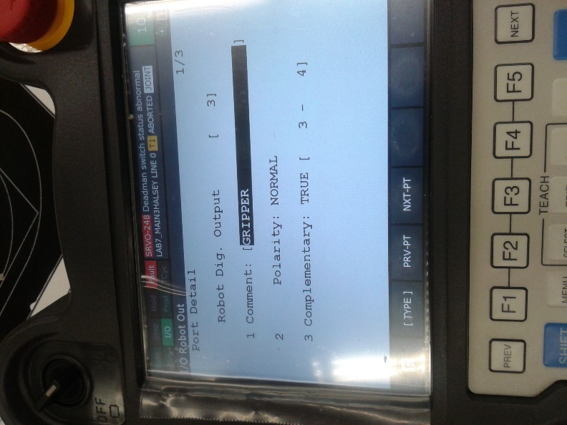 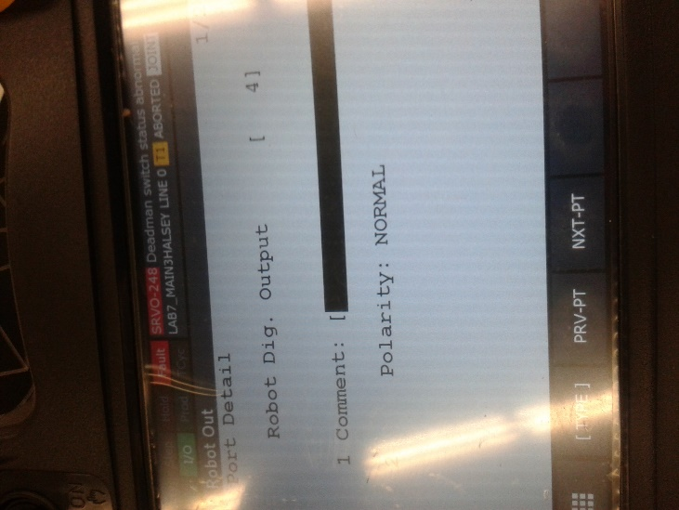 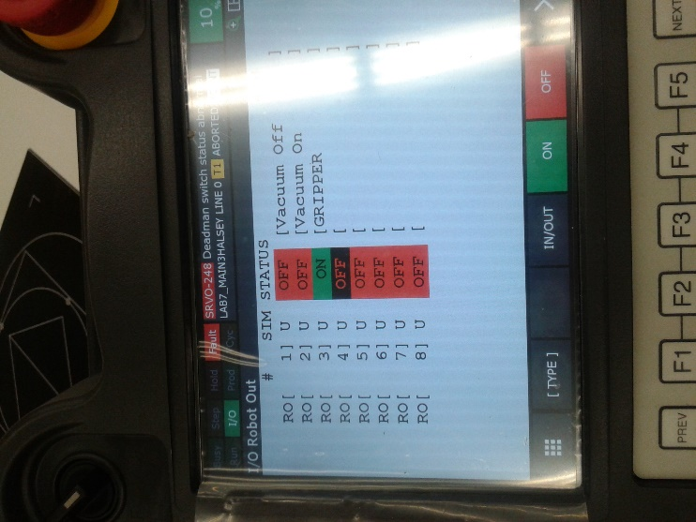

Step 9 Step 10

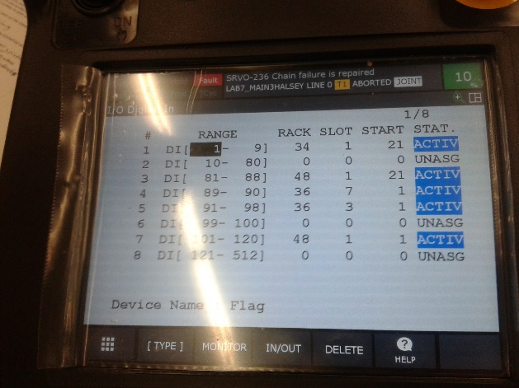 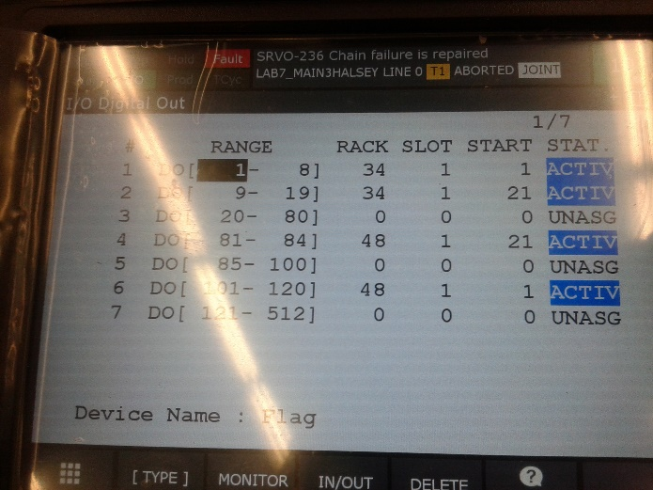

Step 14

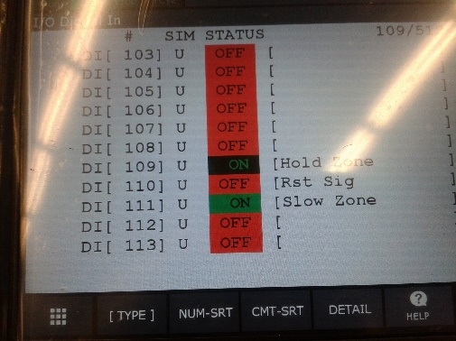

Step 17

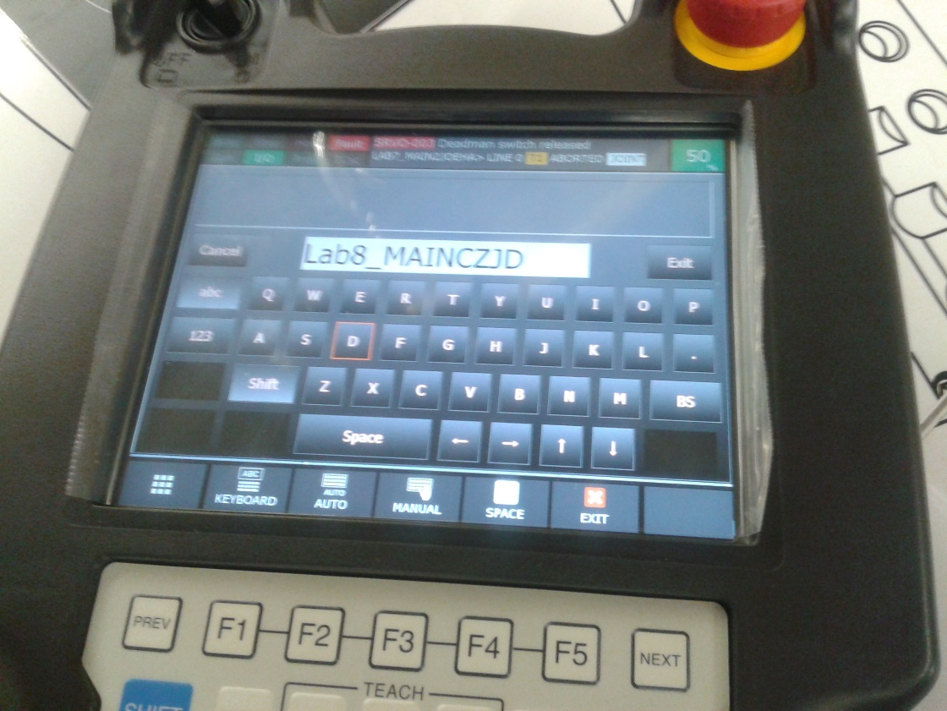 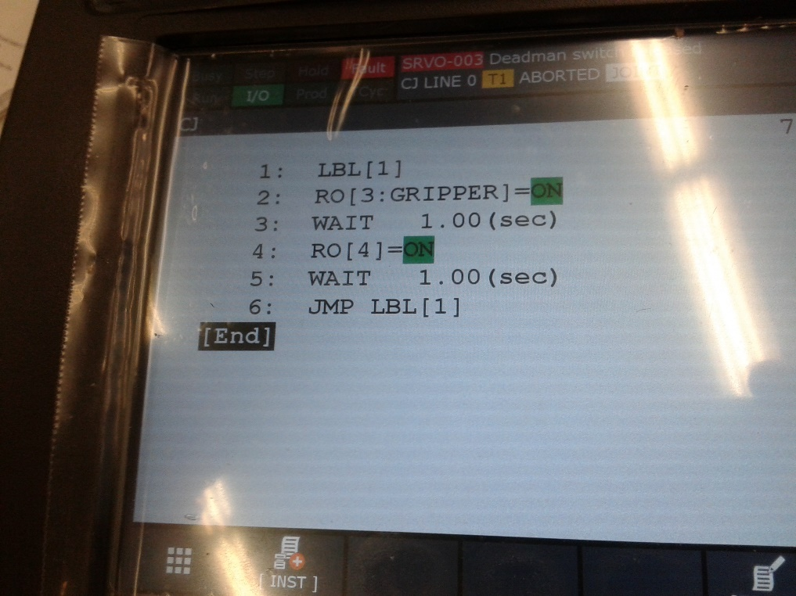

**Analysis Questions:**

1. What are the various types of I/O signals?

***Robot Output Signals:*** *Gripper; Vacuum On; Vacuum Off.*

***I/O Digital Out:*** *IMSTP; *HOLD; *SFSPD; CYCLE START; FAULT RESET; Start; Enable; Laser; Light; Horn; Green Light; Amber Light; Red Light; Small Suction.*

***I/O Digital In:*** *CSC1; CSC2; SVOFF SS; FENCE SS; EXEMG SS; NTED SSI; OPCEMG SSI; AUTO SSI; T1 SSI; T2 SSI; Hold Zone; Rst Sig; Slow Zone.*

1. Why might it be necessary to simulate a digital or robot input?

*To test the inputs, outputs, parts or programs prior to putting the robot into production.*

1. Group I/O is useful for communicating binary information. If Digital Inputs 1 - 4 are configured as GI[1], then what is the value of GI[1] when DI[1] = 1, DI[2] = 0, DI[3] = 0, and DI[4] = 1?

*8+0+0+1 = 9*

*GI[1] = 9*